**Project Design Phase-II**

**Customer Journey Map**

|  |  |
| --- | --- |
| DATE | 04 OCTOBER 2022 |
| TEAM ID | PNT2022TMID27630 |
| PROJECT NAME | Virtual Eye - LifeGuard For Swimming Pools To  Detect |
| MAXIMUM MARKS | 4 MARKS |

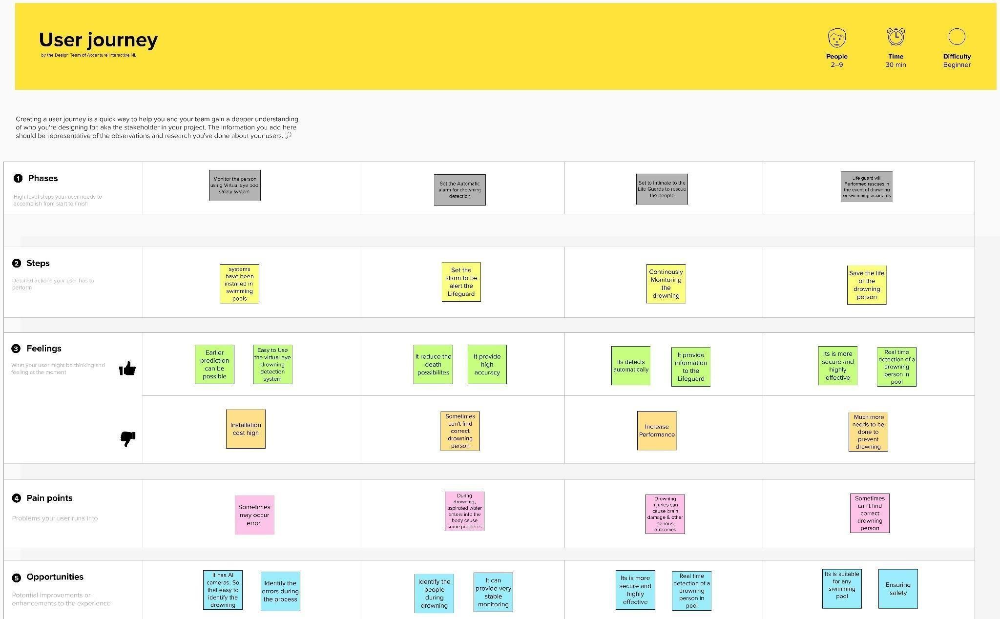Customer Journey Map :